Predictive model of the spread of the spotted lanternfly in the continental United States using machine learning

Erica Keklak and Dr. Wenbo (Selina) Cai
Department of Mechanical and Industrial Engineering
New Jersey Institute of Technology, Newark NJ 07102

The introduction of the spotted lanternfly (Lycorma delicatula) to the continental United States in 2014 caused statistically significant agricultural losses annually due to the insect’s parasitism of plants grown for food, timber, paper, and ornament. Two major aspects of the spotted lanternfly make the species one of the fastest-spreading foreign insect invasions: (1) the variety of plants that L. delicatula parasitizes and (2) their capacity to use land vehicles to rapidly disperse over long distances. Predicting where spotted lanternflies will travel next and where they are most likely to cause significant damage is vital to the economy. Machine learning techniques are already used to predict the diffusion of invasive species around the world, and this project aims to use machine learning to classify the risk of plant damage caused by spotted lanternflies per county and state. Pre-existing Python libraries helped create these decision tree ensembles and neural networks following training, validation, and testing. All models made in this project are intended to predict a general attack risk (to a county or state in the continental United States over the year of 2025 and 2026) or specific risk to all plants grown for the same purpose. Each model uses predictors like local climatological factors, the abundance of predators and host plants, and the high-speed land traffic in each area. The target classes are integers correlated with increasing risk of L. delicatula damaging the plants in the area. The predictors selected for each model in design will be limited in later iterations of each model because not all aspects of climate, ecology, and traffic should improve model accuracy and prevent overfitting. “Final” models, data, and additional commentary will be made available on a public repository. The results will help inform U.S. residents of the high damage potential of L. delicatula and allow agricultural managers to make informed decisions for the end of 2025 and the year 2026.

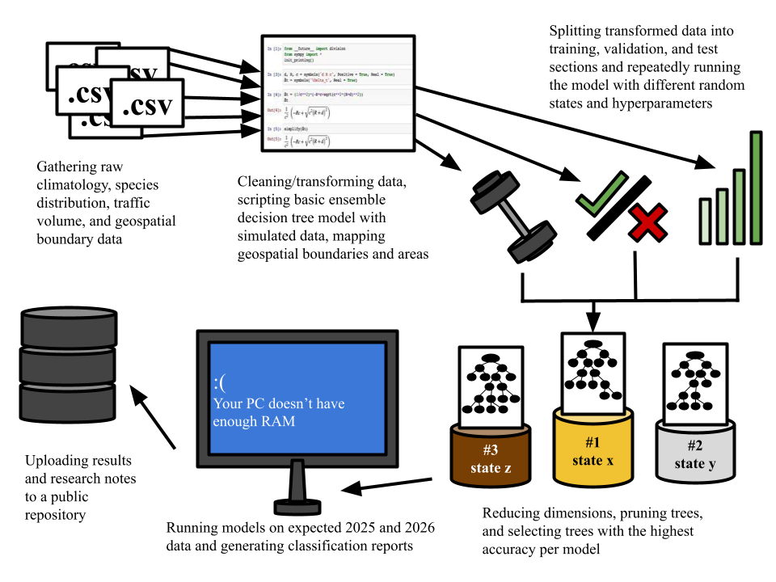
Figure 1: Summary of the research process for decision tree modeling.

